Video Game Project Report
“Elemental Rush”

Elisabeth von Schoenberg (40178878)
Luis Alejandro Gonzalez (40236372)

MECH 415 F
Advanced Programming for Mechanical and Industrial Engineers

Presented to Dr. Brandon W. Gordon (Ph.D.)

Concordia University
Gina Cody School of Engineering and Computer Science
October 2024
For the MECH 415 course, advanced programming for mechanical and industrial engineers, our team has decided to create a simple jumper/scroller game that combines object-oriented programming with 2D graphics, and simple physics.

Game Storyline
The game is set in a mystical world that is under attack of a mysterious dark force. The hero is an inhabitant of the world, who can unlock and transform into various elemental forms that grant them different abilities, helpful to overcome different types of obstacles. The game has no end; however, the players current high score is recorded throughout the game as a metric to see how far the player made it into the world. In addition, the player is given three lives, which can be lost when colliding with an enemy. The game ends when all lives are lost, as depicted by hearts on the screen. The player can run and jump on various platforms throughout the world to help avoid collision with enemies.

The following tables shows an overview of all the game elements and their relations.
Element | Normal | Earth | Water | Air | Time
Elemental  Form |  | 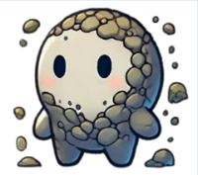 |  |  | 
Fruit | N/A |  |  | 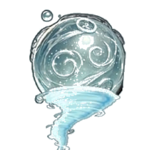 | 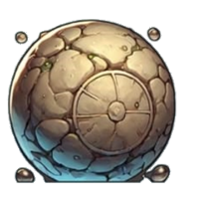
Can Defeat | N/A | 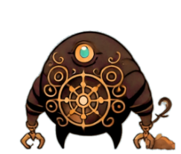 | 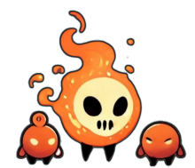 |  | 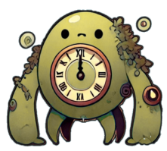
Transform Key | N/A | ‘H’ Key | ‘J’ Key | ‘K’ Key | ‘L’ Key
Power | N/A | Grounded/No Jump | N/A | Double Jump | N/A

Gameplay
NOTE: Before playing, your DirectX window size setting should be as follows.
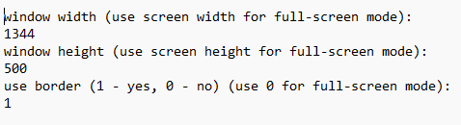
MOVEMENT
Press ‘D’ Key to move forward
Press ‘A’ Key to move backwards
Press ‘W’ Key to jump
TRANSFORMING ELEMENTS
Quick overview:
Press ‘H’ Key to transform to Earth mode
Press ‘J’ Key to transform to Water mode
Press ‘K’ Key to transform to Wind mode
Press ‘L’ Key to transform to Time mode
Detailed Explanation:
To transform to into an element, you must first collect the respective fruit by colliding with it in the game.
If you have the fruit in your bag, the fruit will be displayed in colour in the top bar (shows below).
The letters below the fruit indicate which key to press to activate the respective mode.
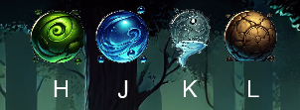
Figure 1 All Fruits in Bag (Colored)
If you do not have the fruit in your bag, the fruit will be greyed out in the top bar. This also indicates the fruit is available somewhere on the game map to be collected.
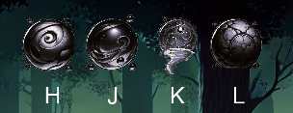
Figure 2 No Fruits in Bag

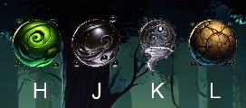
Figure 3 Mixed Bag

When fruits are on the map to be collected, they will appear as shown below.
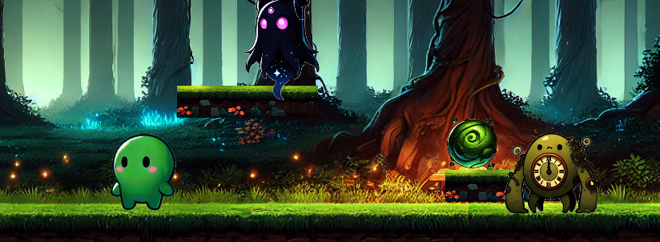

DEFEATING ENEMIES
To successfully defeat enemies, you must first transform into the respective elemental form/mode. This is done by first having the fruit in your bag and secondly activating the change by pressing the respective key on the keyboard.
Example: To defeat the earth enemy the player must be in earth mode
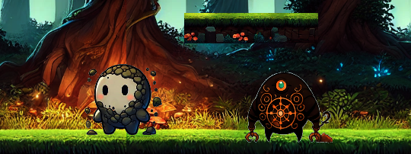
LIVES
The player starts every game with 5 lives, which are displayed in the top right-hand corner as follows.

Every time you collide with an enemy which you cannot defeat, you lose a life. When a life is lost, a heart will be greyed out from the life bar in the upper right-hand corner.
The game ends when you lose all five lives, as shown below.

SCORE
The score is determined by the distance you make it through the map before losing all five lives.
Your maximum score (max distance reached) is displayed in the top left-hand corner of the screen throughout the game.
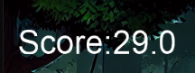
GAME END
The game ends when all five lives lost.

Division of Work
Responsibilities:
Luis Alejandro Gonzalez (50%) | - World class  - Audio Class  - Fruit Class  - Enemy Class  - Elemental Form Class  - UI Class
Elisabeth von Schoenberg (50%) | - Platforms  - Background & Scrolling  - Shuffle Function  (platform, enemy, fruit respawning)  - Main  - Class integrations  - Gameplay/Debugging

